Modelling USD to PKR Exchange Rate Prediction And Trend Using ODE

Alvina Arshad  
CureMD Lahore,Pakistanalvinajee569@gmail.com   
alvina.arshad@curemd.com

***Abstract*—** **This study proposes an approach based on modeling the currency exchange rates trend of USD and PKR by applying ODE analysis. A dataset of the exchange rates between the United States Dollar (USD) and the Pakistani Rupee (PKR) was collected using internet resources. The general development technique of ordinary differential equation is used for forecasting the exchange rate of currency. The result shows the rate to be PKR 171.92 at the end of this year.**

***Keywords—component, formatting, style, styling, insert (****key words****)***

# Introduction

The adoption of a flexible exchange rate has drawn investors and researchers’ interest to explore its effects. The main reason behind this is such high research interest in the exchange rate of a currency as it affects and determines macroeconomic variables for the nation. With the assistance of a country’s competitive exchange rate, the growth rates and other macroeconomic targets can be sustained. The deficiency in trade and insufficient foreign exchange becomes the reason behind the struggling economy of Pakistan.

There is a low output in the country’s export sector and the reason can be due to the small export in the textiles, chemical, pharmaceutical, and other products. Fluctuations in exchange rates create a little effect on export efficiency because of the less competitive exporting products. There have been seen significant changes in the exchange rate policy in recent years. Pakistan is going through bad exchange rate management. According to some studies, the main reason behind competitiveness in the international market is the overvalued exchange rate.[1]

This motivates to consider combinations of forecasting methods for exchange rates. The researcher is using univariate forecasting techniques & the Non-Linear Auto Regressive Distributive Lag (NARDL) model to model the change. These models and techniques focus on exploring the linear and non-linear relationships between exchange rates and the fundamentals of macroeconomics. The development of an effective model is something that can accurately predict the prices of exchange rates for the future. The techniques mentioned and many others like the ARIMA model are used for predicting the foreign exchange rate. [2].

In this paper the approach uses depends on the growth model of the rates in previous years,

# Literature Review

The researchers extensively emphasize combining the time series models, machine learning, and ANN models referring to the combining models for the forecasting exchange rate. Researchers like MacDonald and Marsh combined many time series forecast models to analyze and model the exchange rate of US Doller with British Pound Sterling. They also tried the models to analyze the rate of Deutschemark/USD, and USD/Yen in 1994. In their researches, they demonstrate that the models provide accurate forecasts. Dunis et al were the ones who examined at least sixteen different models for forecasting characteristics and said none of the single models was the optimum one. He added that the mixed model outperformed all other individual models as it had volatility, Neural Network Regression, and other time series models. There were other researchers names as Ince and Trafalis who studied different exchange rates for purpose of forecasting in 2006. He came with parametric and non-parametric methods. The parametric models included ARIMA, VAR models, etc., and incorporate non-parametric models, i.e. (SVR) and artificial neural network (ANN). In his study, he concluded that all parametric models outperform non-parametric models. In 2020 that was a recent study Khasei forecasted the exchange rate by a combination of ARIMA and ANN models. He also concluded that the combined models performed better forecasting than individual models. Some researchers studied and tested the different major global currencies and recommended that combined models.

In 2011 Matroushi suggested two combined models for forecasting exchange rates, i.e., ARIMA-ANN and ARIMA- MLP. He claimed that the combination of these two performed better forecasting than other combined and individual models. In 2016 Wang et al predicted that the ARIMA model with a three-layer ANN Model combination outperform the individual forecasting techniques. There were then many major studies done on the model to see the results. The analysis showed that combined modeling of fundamental models with machine learning outclasses the random walk models. In previous literature, there was an extensive emphasis on a combination of models of the artificial neural network, time series, and machine learning-related models.

Concerning the topic of macroeconomics, Terasvirta and ¨ Anderson included a logistic function to build a smooth transition autoregressive (STAR) model. Gonzalez-Rivera used the research and applied the STGARCH model on stock returns and exchange rates to explore the asymmetric response of conditional variances to positive and negative news. He also applied the nonlinear time series model such as GARCH. Time series forecasting depends on the historical data that helps in predicting the future data points about the exchange rate and others. As mentioned there were hundreds of research done on the time series forecasting to model and predict the exchange rates. There were many strong and weak points in the models but combining two outperforms individuals. The research was done on individual models as well as on the combination of two models and many. Combinations of models were the ones outperforming others.

# Methodology

The given graphs shows the exchange rate of USD to PKR in previous 30-40 years. The data is shows with the years and prices mentioned

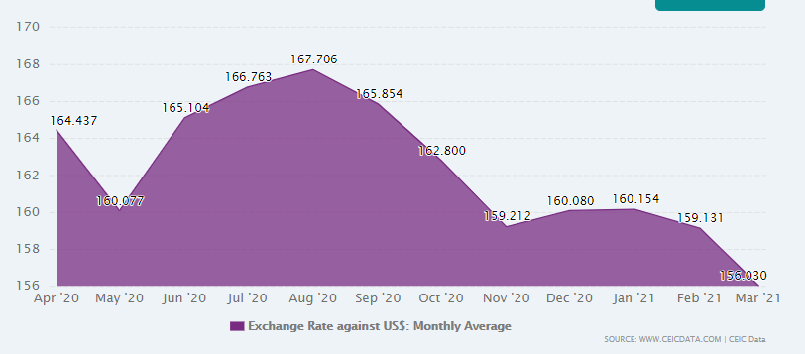

Figure 1: USD To PKR 30 Years

The graphs clearly depicts that the rate has inflation every coming year. From the group if we have to make the prediction we’ll predict that the rate will increase gradually in near future also. The rise in price is clear from the graph. There is very less decrease in the rate and higher inflation that shows that it’s going to get more in future also.

Figure 2 shows the data of 10 years showing the data trend of exchange rate. You can see that the line is going up showing the rise in the 10 years of times.

Figure2: Exhnage Rate of 10 Years

The data clearly depicts that there has been huge increase in the previous 10 years. Let’s have a look at the previous year exchange rate shown in figure 3.

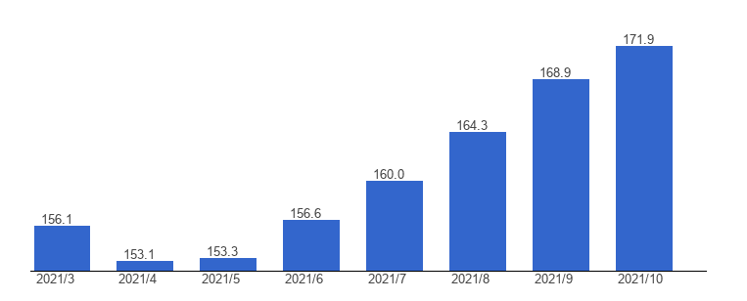

Figure 3: Exchange rate over 1 Year.

To begin developing our model we would take use of the logistic growth model and use dynamic integration to build our model.

$\frac{dN}{dt}=rN(1-\frac{N}{K})$

In the above-mentioned logistic growth model [3-5] equation. The variable N represents the Population size. The variable r represents the growth rate and the variable K represents the capacity which is how much population can sustain in a given environment.

We would consider that our foreign exchange rate is just a function of time without any other parameter involved in it. Now, let us begin developing our equation

Now, let in our foreign exchange case we would define E as the exchange rate. $α and β are paramenters$ that would be tuned to fit the model. Our dynamic equation as a logistic growth model would look as follows:

$\frac{dE}{dt}=β\left(t\right)E(t)(1-\frac{E\left(t\right)}{-β\left(t\right)/α(t)}$

However, we would describe the relationship between the foreign exchange rate, its derivative and acceleration to define our model. Our model is defined as follows.

**Dynamic Transformed Logistic Model**

$\frac{d^{2}E\left(t\right)}{dt^{2}}=α ×{\left(\frac{dE\left(t\right)}{dt}\right)}^{2}+β×\left(\frac{dE\left(t\right)}{dt}\right), (1)$

Where E(t) is the exchange rate at time t.

Assuming that the coefficients $α and β$ are constant during a very short time, we consider the parameterized differential equation with given values of two points at time $to and t1:$

$\frac{d^{2}E\left(t\right)}{dt^{2}}=α ×{\left(\frac{dE\left(t\right)}{dt}\right)}^{2}+β×\left(\frac{dE\left(t\right)}{dt}\right),$

$S\left(to\right)=So$

$S\left(t1\right)=S1$

$to<t1$

And it can be solved as follows. Let,

$v\left(t\right)=\frac{dE\left(t\right)}{dt}$

And

$h=|v\left(to\right)+\frac{β}{\frac{α}{v\left(to\right)}}|$

then the solution is,

$E\left(t\right)=E\left(to\right)-\frac{1}{α}lnln \left|\frac{e^{(β\left(t-to\right) }-h}{1-h}\right| ,$

$if\left(v\left(t\right)+\frac{β}{α}\right)×v\left(t\right)>0,v\left(t\right)>v\left(to\right), E\left(t\right)>E(to)$;

$E\left(t\right)=E\left(to\right)-\frac{1}{α}\frac{|β|}{β} lnln \left|\frac{e^{(β\left(t-to\right) }-h}{1-h}\right| ,$

$if\left(v\left(t\right)+\frac{β}{α}\right)×v\left(t\right)>0,v\left(t\right)>v\left(to\right), E\left(t\right)<E(to)$;

$E\left(t\right)=E\left(to\right)-\frac{1}{α}lnln \left|\frac{e^{(β\left(t-to\right) }+h}{1+h}\right| ,$

$if\left(v\left(t\right)+\frac{β}{α}\right)×v\left(t\right)<0,v\left(t\right)>v\left(to\right), E\left(t\right)>E(to)$;

$E\left(t\right)=E\left(to\right)-\frac{1}{α}\frac{|β|}{β} lnln \left|\frac{e^{(β\left(t-to\right) }+h}{1+h}\right| ,$

$if\left(v\left(t\right)+\frac{β}{α}\right)×v\left(t\right)<0,v\left(t\right)>v\left(to\right), E\left(t\right)<E(to)$;

$E\left(t\right)=E\left(to\right)+\frac{1}{α}\frac{|β|}{β} lnln \left|\frac{e^{-(β\left(t-to\right) }-h}{1-h}\right| ,$

$if\left(v\left(t\right)+\frac{β}{α}\right)×v\left(t\right)>0,v\left(t\right)<v\left(to\right), E\left(t\right)>E(to)$;

$E\left(t\right)=E\left(to\right)-\frac{1}{α}lnln \left|\frac{e^{-(β\left(t-to\right) }+h}{1+h}\right| ,$

$if\left(v\left(t\right)+\frac{β}{α}\right)×v\left(t\right)>0,v\left(t\right)<v\left(to\right), E\left(t\right)<E(to)$;

$E\left(t\right)=E\left(to\right)+\frac{1}{α}\frac{|β|}{β} lnln \left|\frac{e^{-(β\left(t-to\right) }+h}{1+h}\right| ,$

$if\left(v\left(t\right)+\frac{β}{α}\right)×v\left(t\right)<0,v\left(t\right)<v\left(to\right), E\left(t\right)>E(to)$;

$E\left(t\right)=E\left(to\right)+|\frac{1}{α}|lnln \left|\frac{e^{-(β\left(t-to\right) }+h}{1+h}\right| ,$

$if\left(v\left(t\right)+\frac{β}{α}\right)×v\left(t\right)<0,v\left(t\right)<v\left(to\right), E\left(t\right)<E(to)$

Our model depicts the relationship between velocity and acceleration of the foreign exchange rate.

$\frac{dE}{dt} (velocity)$

$\frac{dE^{2}}{dt^{2}} (acceleration)$

The relationship is based on the logistic growth model. We can see that when $α$ is negative and $β$ is positive, the velocity moves in the way of as depicted by the logistic growth model. That is the velocity reverses its direction to an implied equilibrium velocity so that the foreign exchange rate goes up or down with an approximately constant speed. While in all of the other cases of combinations of $α and β$, the velocity diverges and hence the foreign exchange rate fluctuates more dynamically.

# Numerical Results and Discussion

# Recommendations to the company

Figure 4 shows the exchange rate of more than 20 years of USD to PKR. We can predict the graph itself that it’s going to increase shortly.

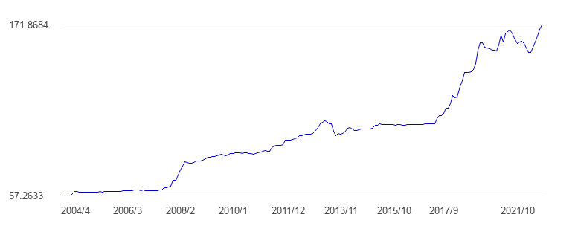

Figure 4: USD-PKR 20 Years

The prediction based on the calculation shows that the exchange rate is going to be around 179 rupees.

The trend shows that there are complete spikes and rises in the chart that are not sudden and rising gradually. There are lesser points where the graph is going down otherwise rising. Some points show the drastic increase in the exchange rate during some years. The prediction can be made from the graph that it’s going to increase in near future. The reasons can be economic issues or some misalignment. Many factors can make this model more perfect like time series and some other factors for time relevant to make it more machine learning and artificially intelligent.

My suggestions will be that the company must do finance as considering the factors the price is around 179 and is going to increase in the near future.

##### References

1. koreascience.or.kr/article/JAKO202109554061363
2. Al-Gounmein, R. S., & Ismail, M. T. (2020). Forecasting the exchange rate of the Jordanian Dinar versus the US dollar using a Box-Jenkins seasonal ARIMA Model. International Journal of Mathematics and Computer Science, 15(1), 27-40. <http://ijmcs.future-in-tech.net/15.1/R-AlGounmeein.pdf>
3. Amat, C., Tomasz, M., & Gilles, S. (2018). Fundamentals and exchange rate forecast ability with machine learning methods. Journal of International Money Finance 88, 1-24. <https://doi.org/10.1016/j.jimonfin.2018.06.003>
4. Alshammari, T. S., Ismail, M. T., Al-Wadi, S., Saleh, M. H., & Jaber, J. J. (2020). Modeling and forecasting Saudi stock market volatility using wavelet methods. The Journal of Asian Finance, Economics, and Business, 7(11), 83-93. <https://doi.org/10.13106/jafeb.2020.vol7.no11.083>
5. Altavila, C., & Grauwe, D. P. (2008). Forecasting and combining competing models of exchange rate determination. Applied Economics, 42, 3455-3480. <https://doi.org/10.1080/00036840802112505>
6. P. F. Verhulst, “Recherches Mathematiques sur la Loi D’accroissement de la Population (mathematical researches into the law of population growth increase),” Nouveaux Memoires de l’Academie Royale de
7. P. F. Verhulst, “Deuxieme memoire sur la loi daccroissement de la population,” Memoires de l’Academie Royale des Sciences, des Lettresetdes BeauxArtsdeBelgique,vol.20, pp.1–32, 1847.